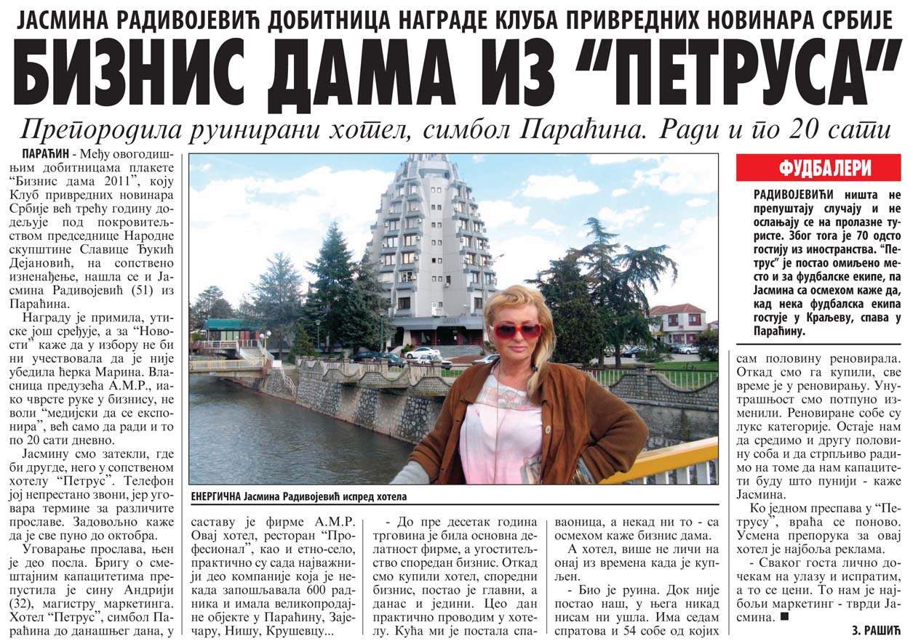

|  |  |  |  |  |  |
| --- | --- | --- | --- | --- | --- |
| **Datum:** | 03.04.2012 | **Novina:** | Večernje Novosti Srbija | | |
| **Rubrika:** | Srbija | | | **Strana:** | 18 |