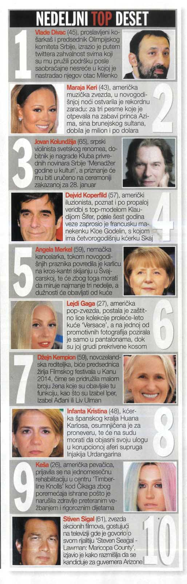

|  |  |  |  |
| --- | --- | --- | --- |
| Datum: | **13.01.2014** | Novina: | **Gloria** |
| Rubrika: | **Bez Rubrike** | Strana: | **09** |