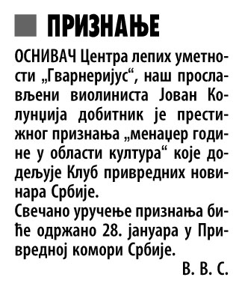

|  |  |  |  |
| --- | --- | --- | --- |
| Datum: | **10.01.2014** | Novina: | **Večernje Novosti** |
| Rubrika: | **Kultura** | Strana: | **15** |